Albania participates at the 10th International Cultural Festival “ Balkan Trafik”

With Vikena Kamenica &Keli Band – Ali Pasha Group

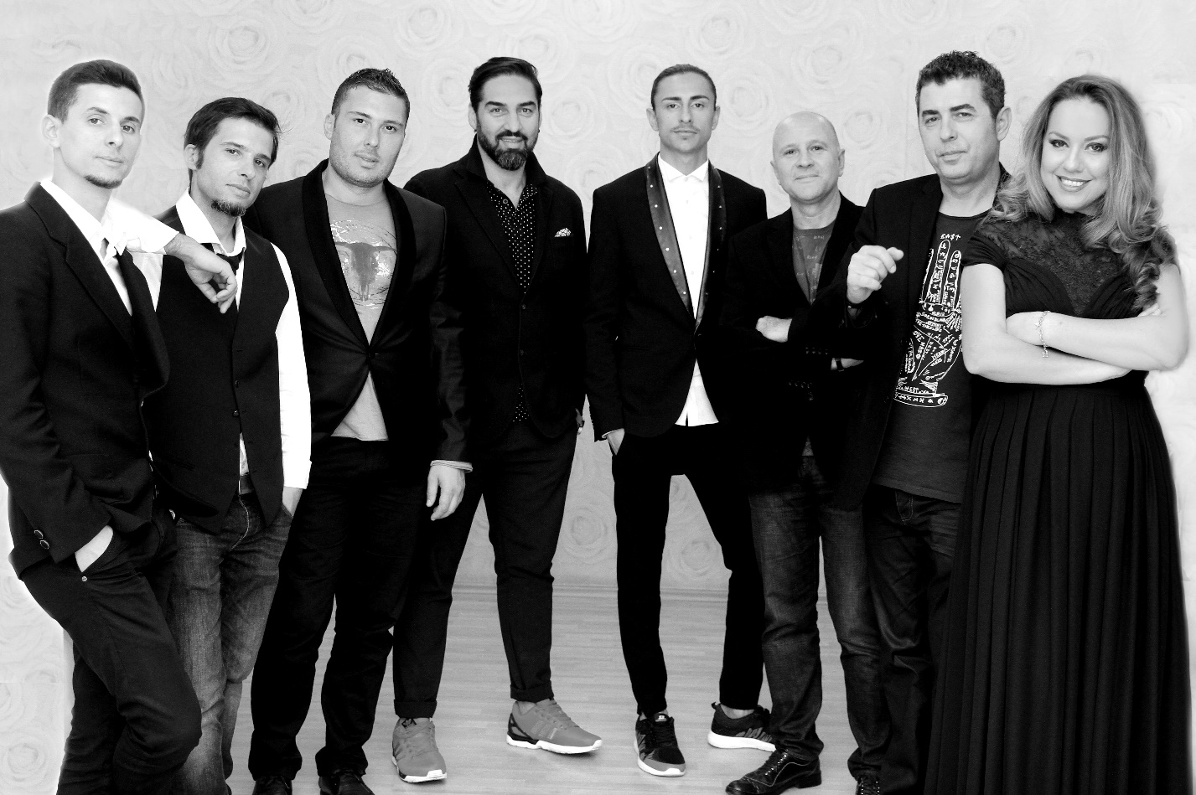

Thanks to the support and sponsorship by the Ministry of Culture of the Republic of Albania and in cooperation, with its Embassy in Brussels, during the 10th International Festival “ Balkan Trafik” in Brussels that will take place from 14 – 17 April 2016, Albania will be represented with the well-known singer Vikena Kamenica, the Keli Band and the famous Ali Pasha folk Group.

This high profile participation from Albania promises the success at this major cultural event of the countries of our Region in the European Capital.

Our artists will be present during the Festive Opening of the Festival on 14 April 2016, from 20 – 20:30 Hours.

Apart from the official Concert on 16 April in the afternoon at BOZAR, the Albanian artists will be Special Guests and perform at the most characteristic Square “ Grande Place” on 17 April at 12:00 Hours and in other venues, together with the dancers of “ VATRA”

For more Info on the timetable of these performances and the tickets, please browse through www.Balkantraffik.com

Mezzosoprano Vikena Kamenica is one of the most popular singers and performers of her generation in Albania. The daughter of two opera singers, Vikena excelled during her undergraduate studies and, in particular, during her graduation at the Tirana Music Academy in 2001. Between 2004-2006, she continued her studies at the CEE Music - Theater in Vienna.

In 2008, Vikena was awarded the prestigious Sommer Akademie Mozarteum Salzburg grant In 2009, she won the celebrated “Cult” award, a cultural competition held on an annual basis in Albania.

As of 2001, she has been working as a Soloist at the Albanian National Theatre of Opera and Ballet. She has performed in a series of famous classic roles, including Fidalma in Cimarosa’s Il Matrimonio Segreto, Suzuki in Puccini’s Madame Butterfly, Flora in Verdi’s La Traviatta, Anita in Bernstein’s West Side Story, Frau Pichem in Weill’s The Three-penny Opera, Siebel in Gounod’s Faust, and the Third Dame in Mozart’s Magical Flute.

She has excelled on stage with new productions in Bucharest and Timisoara, Romania, at the Festival de Sedieres, France and in other countries together with Albanian internationally - recognized artists as soprano like Inva Mula, tenor Saimir Pirgu and others.

She was also brilliant in the New Year’s Gala Performance, accompanied by the New Philharmonic Orchestra, and in a recital (When the two of us are together) together with Kastriot Tusha, the renowned Albanian tenor, with the New York Philharmonic Orchestra.

Vikena is also well-known in Albania as a jazz singer and for her performances in musicals, and, as such, she regularly makes guest appearances on various TV stations. Some of the most special concerts include “The Napoletana” in which she performed with the orchestra of the National Academy of Arts and” Le Temps de Cerises” together with wonderful actors. These were followed by performances as a solo singer with Theater International – Musical in a wonderful selection of musical pieces celebrating 100 Years of Broadway, as Esmeralda in Notre Dame de Paris, Mrs Montague in Romeo and Juliette, Mama Morton in Chicago, etc.

“ KELI BAND” is a musical formation set up in 2008 by its leader, the saxophone player, Brikel Gunga. This band is composed by professional musicians, largely Albanians.

Their repertoire is rich with various musical trends, which range from jazz to experimental ones.

They have taken part in different jazz festivals and are incorporated in a number of musical projects in Albania and abroad.

Besides the involvement in musical trends, recently “Keli Band” has succeeded in its experiment, by fitting Albanian traditional sounds and melodies to the modern alternatives; thus, they have brought a new development and novelty in the Albanian music and wider.

In the last couple of years, “ Keli Band” has produced a musical collection “Independent Days" largely in the Jazz Standard and the "Night Love" ; they have also included their own creations in both collections.

After its successful presentation in major projects launched by the Ministry of Culture in 2015 ( The National Folklore Festival of Gjirokastra and others) “Keli Band” is making preparations for the next projects.

During 2016, “Keli Band” will be present during most of this year through launching the new musical album” "RRENJE TE LARGETA"( REMOTE ROOTS” in cooperation with the prominent singer Vikena Kamenica; accordingly, they will add more perfume to their musical career and creativity.

“ ALI PASHA” Folk Musical Band was set up in 1992 in the small town of Tepelena in Southern Albania, the native town of the Ali Pasha Tepelena, one of the most prominent historical figure of Albanian history during the 18th Century.

This band became first known in the south after attending local events on continual basis in this area and in various national festivals.

Its popularity grew up especially when it released the first musical album in the year 2000 and the second in 2002. The first Album hit one of the largest sale records in terms of folk and cultivated music.

This band has become famous by virtue of interpreting the folk southern, cultivated, ethno-folk and even ethno-jazz music.

The band has in its repertoire nearly 100 musical pieces, with 30 songs as direct creations by its members.

With the passing of time the band has changed, refreshing itself with new artists; nonetheless its nucleus remains the famous duo Alfred Shehu and Ferdi Ibrahimi.

“ Ali Pasha” Band has taken part in the most notable shows of Albanian most prestigious televisions – “The Marathon of Folk Songs”, “100 best songs of the Century”, “100 Years with Music” and the Gate of Fate” by “ Clan “Television; Top Show in the TV “ Top Channel”; “ The Folk Music Festivals” in the Albanian Public Television and other events.