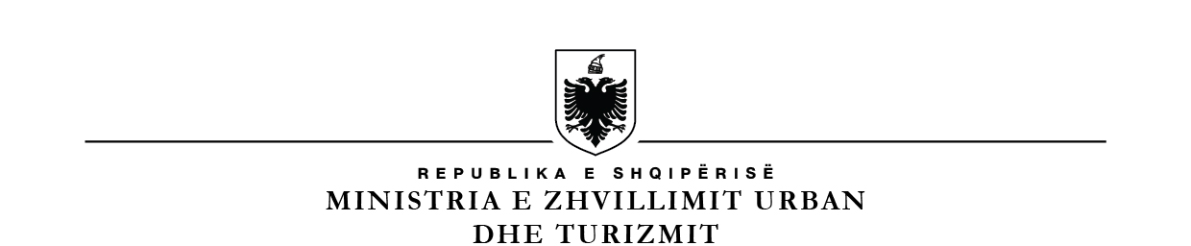

**MINISTRY OF URBAN DEVELOPMENT**

**NATIONAL TERRITORIAL PLANNING AGENCY**

### No. ________Ref. Tirana, on ____.____.2015

**CONTRACT NOTICE**

1. Contracting Authority: **National Territorial Planning Agency (NTPA)**

with address at: Rruga “Muhamet Gjollesha”, Nr.57, Tirana,

Tel/Fax: +355 42272556.

1. Type of procurement procedure: **Consulting Services (in 2 phases)**.
2. Contract Name: “**Detailed design of rehabilitation of National Theatre of**

**Opera and Ballet and Folk Ensemble”**

1. Limit Fund: **30.318.750 Albanian Leke (VAT excluded)**
2. Source of financing: State Budget - Government of Albania.
3. Deadline for services delivery: within 60 days from signing of contract.
4. Submission of Applications Deadline, date and time: **22.06.2015, at 16.00 (local time)**

place: The first phase (shortlisting phase) will be carried out by electronic means at website: [www.app.gov.al](http://www.app.gov.al)

1. Applications Opening Deadline, date and time:  **22.06.2015, at 16.00 (local time)**

place: The first phase (shortlisting phase) will be carried out by electronic means at website: [www.app.gov.al](http://www.app.gov.al)

**HEAD OF THE CONTRACTING AUTHORITY**

**Adelina GRECA**