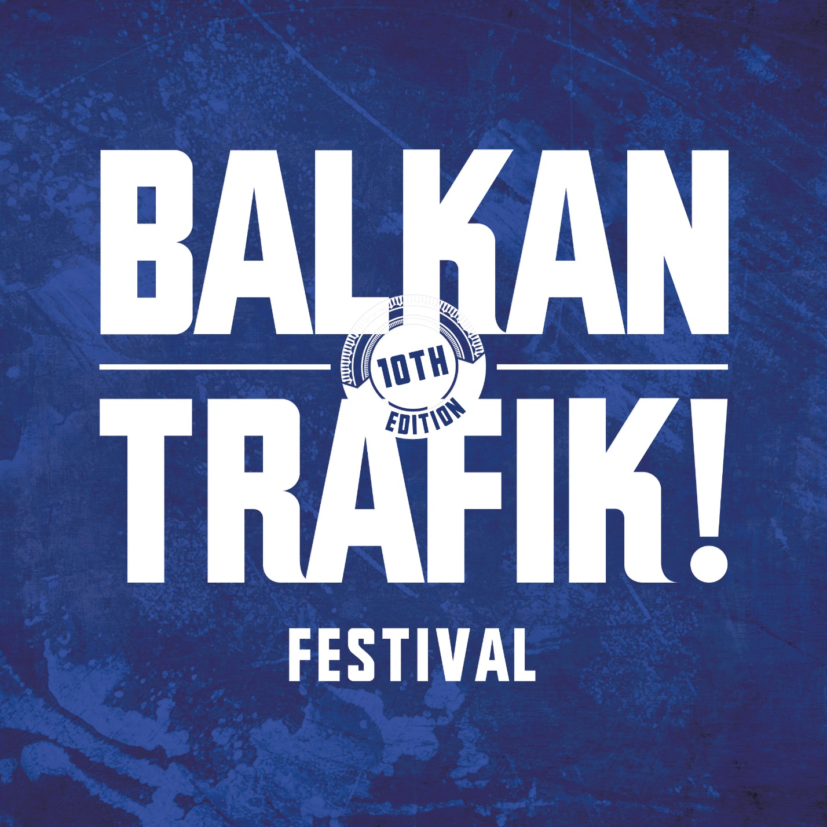

Albania at the 10th Edition of the International Cultural Festival “ Balkan Trafik “

Brussels, 14 – 17 April 2016

Supported and sponsored by the Ministry of Culture of the Republic of Albania in cooperation with its Embassy in Belgium.

From 14 – 17 April 2016, “BOZAR” the Center for Fine Arts in the heart of Brussels will host for the tenth time in succession the International Cultural Festival “ Balkan Trafik”

For 4 consecutive days, not only the interior and exterior premises there, but also “ Grande Place” and other squares will echo the best values, songs, dances, music and culture of the Southeastern European and other countries.

At this jubilee edition, Albania will take part with its prominent signer and performer Vikena Kamenica, the “Keli Band” and the well-known Folk Group “ Ali Pasha”.

Present at this major cultural event will also be the Albanian Folk Ensemble “VATRA”

Our artists will be present during the Festive Opening of the Festival on 14 April 2016, from 20 – 20:30 Hours.

Apart from the official Concert on 16 April in the afternoon at BOZAR, the Albanian artists will be Special Guests and perform at the most characteristic Square “ Grande Place” on 17 April from 12:00 Hours and in other venues, together with the dancers of “ VATRA”

Likewise, in the margins of this Festival, a tourist stand will stay open at BOZAR with a large number of tourist guides and folders on the developments and huge opportunities of tourism in Albania and in Kosovo.

Just as last year, the members of the active Student Association “ VLERA” will be there to provide their recognized contribution.

Albania’s participation at this cultural event, the largest of this kind in Europe became possible thanks to the support and sponsorship by the Ministry of Culture of the Republic of Albania in cooperation with its Embassy in Belgium.

It is also a product of the assistance and support provided by its organizers, the non-profit company “ 1001 Valises” and its Director General, Mr. Nicolas Wieërs.

All our fellow citizens are invited together with their foreign friends and well-wishers to become part of this remarkable cultural and artistic manifestation.

For more Info on this Festival, the program of concerts/performances and tickets, please click on [www.balkantrafik.be](http://www.balkantrafik.be) as well as in the website of the Embassy of Albania in Belgium and the Mission to the EU.

**Agenda of concerts and animations of by “Viena Kamemica&Keli Band -Ali Pasha at the International Cultural Festival “ BALKAN TRAFIK “**

**BRUSSELS, 14 – 17 APRIL 2016**

Thursday, 14 April 2016

At “ Vino Zirkus” – Bozar 20:00 – 20:30 Hours

Friday, 15 April 2016

At Vino Zirkus” 19:00 – 19:30

Saturday, 16 April 2016:

HALL «  M » 17:30 – 18:15 Hours, the Official Concert

At «  Vino Zirkus » 22:45 – 23:15 Hours

Sunday, 17 April 2016:

At Grand Place: Giant Horo starting at 12:30 with our band performing at 16:30 – 17:00 Hours as a “ Guest of Honour”